COVID-19 Situation in Korea

- Characteristics of the COVID-19 Situation in Korea
- The confirmed COVID-19 cases in Korea so far have largely been accounted for by a specific region and a single religious group, Shincheonji Church.
- The COVID-19 outbreak in the region began in early February, and has spread rapidly among the members of the Shincheonji Church in Daegu. Evidence points to a mass gathering of thousands of the Church members in Daegu on 1 Feb as when and where the quick spread began. Since then, the estimated 9,300 members of the church in Daegu have been placed on self-quarantine and tested. All other members of the Church around the country – more than a quarter-million - have mostly been tracked, questioned, and tested when they report symptoms.
  - As of March 15th, 61% of confirmed cases are linked to Shincheonji Church and 88% are residents in Daegu/North Gyeongsang Province.
- The number of confirmed cases in regions outside Daegu/North Gyeongsang Province remains at around 974, well within our disease control capacity. Sporadic spikes in group/community transmission in other parts of the country, e.g. the recent case of a call center in suburban Seoul, are being quickly contained.
- The number of new confirmed cases per day has been showing steady decline since hitting a peak at 909 new cases in February 29th. On March 13th, the number of patients who had fully recovered, tested negative for COVID-19, and released from hospitals or treatment centers (shown in red) has begun to surpass that of the new confirmed cases (shown in blue), as can be seen in the graph below.
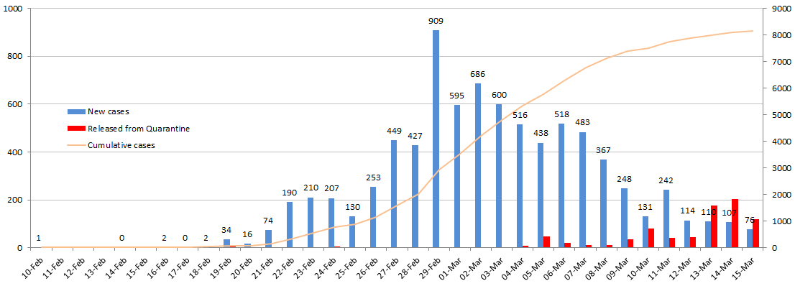
< COVID-19 Situation in Korea >
- Korean Government’s Quarantine Capability
- The rapid increase in the number of confirmed cases in Korea has been due to ▴our government's capacity to run up to 18,000 diagnostic tests per day and ▴our intensive epidemiological analysis of high-risk groups. The daily increase in the number of confirmed cases in Korea is a testament of our government’s thorough diagnostic screening and quarantine response that aims to ‘pursue and track down’ potential cases by intensively focusing our capabilities to specific high-risk groups.
- (Diagnostic Screening Capability) As of March 15th, the cumulative number of diagnostic tests conducted in Korea has reached 268,212. This translates into roughly 1 out of 193 persons in Korea having been tested, an overwhelmingly high ratio compared to other affected countries.
- The diagnostic tests are conducted by a total of 117 testing institutions across the nation including the Korea Centers for Disease Control, 4 National Quarantine Stations, 18 Research Institutes of Public Health and Environment, and 94 private medical laboratories and hospitals. The cumulative number of diagnostic tests includes those for individuals tested multiples times.

- (Innovative Sampling : Drive-through Testing Stations) To cut time needed for diagnostic screening, and limit exposure of front line medical workers as well as those that are waiting to be tested, our Government has pioneered Drive-through Testing Stations, allowing drivers to go through the process of registration and sample-taking procedures in under 10 minutes without needing to get out of their vehicles. This minimizes both pressure on hospitals and transmission risk by keeping potential patients out of hospital waiting rooms, and cuts time by eliminating the need for surface disinfection and other infection control measures needed for sample-taking within hospital walls. There are approximately 50 drive-through testing stations being operated around the country, and more are being constructed nationwide.
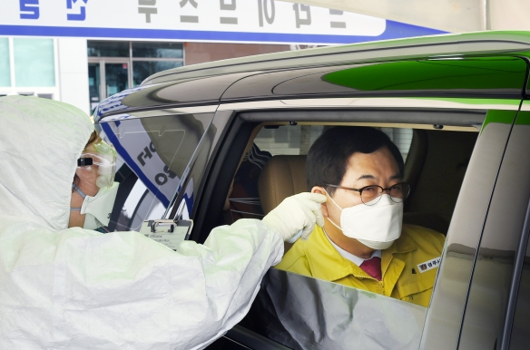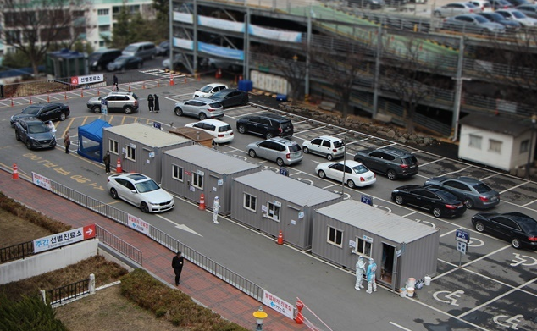
< Drive-through Testing Stations in Operation>

- (Rigorous Epidemiological Investigations and Monitoring of Contacts) Our Government is undertaking vigorous measures to track and test those who had been in contact with confirmed cases, utilizing credit card transaction history, CCTV footage and mobile phone GPS data when necessary. Relevant anonymized information is disclosed to the public so that those who may have crossed paths with confirmed cases may get themselves tested. Close contacts identified through epidemiological investigations are put under self-quarantine and monitored on a one-on-one basis by staff of the Ministry of Interior and Safety and local governments.
  - Also, the close contacts under self-quarantine are linked to their assigned government staff through an innovative ‘safety protection app’, which allows the staff to monitor their symptoms twice daily and be alerted when self-quarantine is broken. This tracking of the phone’s GPS location is done only with the consent of the close contacts. .
  - The extensive screening goes so far as to conduct postmortem diagnostic tests on deaths with unknown causes if the deceased had shown symptoms of pneumonia or other possible markers that point to COVID-19 infection. When confirmed, we track and monitor all those who had been in close contact with the deceased before death.
  - Hospitals and pharmacies have been granted access to patients’ travel histories to a select number of highly affected countries and areas such as China, Japan, Iran and Italy to aid in the screening of suspected cases of COVID-19 infection.
- (Concentrated Testing on High-risk Groups) As early symptoms of the COVID-19 infection is nearly indistinguishable from those of the common cold, the Government has expanded testing protocols to include those displaying symptoms of the common cold within Daegu, a high-risk region, regardless of whether they had contact with confirmed cases.
- At the same time, the Government is focusing on speedy recovery of those infected with COVID-19 through our advanced medical care.
- Although COVID-19 infection can manifest with little or no symptoms, the sheer diagnostic capability of our Government makes early detection possible, thereby providing treatment at the earliest possible stage, and increasing the likelihood of successful recovery. As a result, the mortality rate of COVID-19 related deaths in Korea has been kept very low at 0.8% (as of March 14th), and most of the related deaths have been either among the elderly or those with existing medical conditions.
- In the early phase of the outbreak, the Government made hospitalization mandatory for all confirmed cases regardless of the severity of symptoms. However, facing a shortage of hospital beds after the Shincheonji outbreak in Daegu and surrounding suburbs, the Government decided to prioritize our medical resources to those that are in need of treatment. The confirmed cases that have little need for medical care are now being accommodated under quarantine in temporary treatment facilities (called “living treatment centers”) and monitored for symptoms.
  - A Patient Management Team composed of medical professionals categorizes confirmed cases into four groups according to the severity of their symptoms. Those in the mildest group are accommodated in the temporary treatment facilities and those in the remaining three groups are immediately put under hospital care in national infectious disease hospitals or other government-designated medical institutions. Those quarantined in treatment facilities that develop more serious symptoms requiring treatment are promptly be put under hospital care.
- The number of new confirmed cases in Korea had surged for some time after the 31st patient, a member of the Shincheonji church, was detected on February 18th. Since then, our diagnostic capabilities were concentrated to the high-risk groups (Shincheonji church and Daegu/North Gyeongsang Province) for the past few weeks. As concentrated testing for these high-risk groups has come to a close, the number of daily new confirmed cases has come down significantly.
- The number of new confirmed cases: Feb. 29 (909) → Mar. 3 (600) → Mar.9 (248) → Mar.14 (107) / As of March 14th, the number of new confirmed cases detected per day has fallen by 88% compared to the peak number of new cases on February 29th.

- Korean Government’s Prevention of the COVID-19 Inflow from Abroad
- Even without a full entry ban on those visiting from other affected countries, the Korean government has effectively blocked inflow of infection through comprehensive and watertight quarantine measures.
- In the early stages of the COVID-19 situation in January when the outbreak was confined mostly to China, ‘Special Entry Procedure’ at international airports and ‘Self-Diagnosis Mobile App’ for smartphones was introduced, while imposing entry ban only on the single most affected province of China.
- Prior to the COVID-19 outbreak, the number of foreign nationals entering Korea from China was around 20,000 per day. Currently, that number has fallen to around 400 per day, a 98% decrease. The total number of foreign nationals entering Korea from China in February decreased by 78% compared to that in January.
- The considerable drop is the result of various measures the Korean government has taken, such as an ▴entry ban against Hubei Province, ▴Special Entry Procedures for travelers from China including Hong Kong and Macao, ▴suspension of visas issued by our Consulate General in Wuhan, ▴tightening of visa issuance procedures, ▴suspension of visa-free entry to Jeju Island, ▴suspension of visa-free transit to third countries vis-à-vis foreigners originating from China, and ▴reduction in flights and ferry services. The Chinese Government’s banning of Chinese nationals’ group tour abroad and limiting individual travel have also contributed to the reduction.
- Considering that universities in both Korea and China start their academic year in March, the respective Ministries of Education have jointly declared an advisory for the students currently in their home country to refrain from entering their country of study as a preemptive measure. The students that do enter their country of study are required to conduct self-quarantine measures for 14 days.
- (Special Entry Procedure) The Special Entry Procedure was first introduced on February 4th, and has been applied to all inbound travelers, foreign and domestic, travelling from China. Since then, the Special Entry Procedure has been expanded to include other COVID-19 affected countries and regions such as Hong Kong and Macao (Feb. 12th), Japan (March 9th), Italy and Iran (March 12th), and all European countries (March 16th). This has proved to be highly effective in monitoring inbound travelers for 14 days after their arrival in Korea. All inbound travelers are required to enter a separate entry hall for immigration, where they undergo fever checks, submit Health Questionnaires and Special Travel Records Declaration, which records their contact information and address in Korea. Our immigration officials check, on site, whether the travelers can be reached via the phone number provided. Entry is denied if they do not provide a reachable phone number.
- As of March 14th, a total of 124,690 foreign and domestic travelers have entered Korea through the Special Entry Procedure.
- (Self-Diagnosis Mobile App) The in-bound travelers are also required to install the Self Diagnosis App on their smartphones and submit their health status every day on the app for 14 days. If they show symptoms of early COVID-19 infection for more than two consecutive days, the Korea Center for Disease Control and local authorities follow up to take the necessary measures. Those who neglect to submit their health status are tracked down by health authorities to identify their location and health status. Of all the travelers monitored through the Self-Diagnosis Mobile App, as of March 11th, 985 cases were followed up by health authorities based on their submission of health status. Of those, 155 were tested for COVID-19 and all confirmed negative.
- Self-Diagnosis Mobile App statistics as of March 12th (accumulated since February 12th): △installation rate 88.5%, △health status submission rate 86.9%
- Those unable to download the app on their phones (the elderly, 2G phone) are reached and monitored through a call center for 14 days.
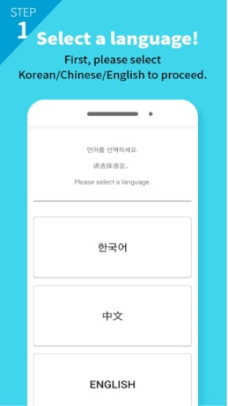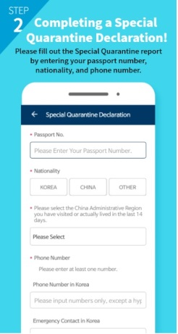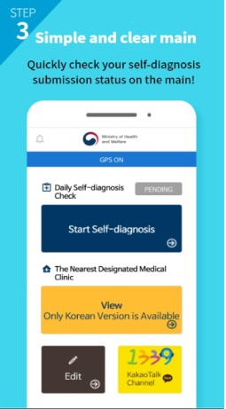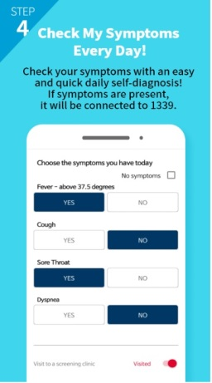
<Self-Diagnosis Mobile Applications>
- Korean Government’s Prevention of COVID-19 Outflow Overseas
- In accordance with our relevant domestic laws (Quarantine Act Clause 24), the Korean government prohibits individuals identified as COVID-19 “contacts*” from exiting Korea during their 14 day self-quarantine regardless of whether they are symptomatic of COVID-19 or not.
- Persons who have been within 2 meter distance from an infected patient, starting one day before the patient showed symptoms, etc.
- A government official is assigned to each “contact”, who calls twice a day to check their whereabouts and symptoms during the self-quarantine period.
- Relevant domestic laws have been revised to allow heavier penalties (imprisonment up to one year and/or up to a fine of KRW10,000,000) upon violation of self-quarantine.
- As of March 12th, over 22,000 Koreans, identified to have had contact with confirmed cases, have been banned from exiting the country.
- (COVID-19 Free Airport) Pledging to become a ‘COVID-19 Free Airport’, Incheon International Airport has implemented a full-fledged three step temperature monitoring program on outbound passengers. Temperature checks are conducted at the terminal (1) when entering the departure hall and (2) before entering the security check point (with thermal cameras / when detected with higher body temperature, with non-contact thermometers for more accurate results), and (3) at the boarding gate (with non-contact thermometers). When confirmed to have a fever of 37.5°C or higher, passengers are escorted to the National Quarantine Office for further inspection and may not be allowed to board.
- In addition, Incheon International Airport has further strengthened disinfection protocol of its facilities, including special sterilization of check-in counters and security search equipment three times a day. Facilities that are exposed to physical contact with passengers such as elevators and escalators are also disinfected with alcohol three times a day.
- Currently, similar measures are being implemented in other international airports in Korea.
- Open and Transparent Response with Minimal Interference in Traffic
- The Korean Government is committed to complying with WHO recommendations i.e. that measures in relations to international traffic that significantly interfere with the movement of people and goods during public health emergencies, need to be proportionate to the public health risk, be short in duration, and be reconsidered regularly as situation evolves.
- The Korean Government’s adherence to the principles of openness, transparency and minimal interference to international traffic has been consistently applied to both inbound and outbound policies.

OVERSEAS
Quarantine
Management
Zones
Travel Alerts
KOREA
Self-Diagnosis App
Monitoring
Public Awareness

Special Entry Procedure
Temperature Checks
Open and Transparent Response with Minimal Interference in Traffic

- The Korean Government is fully committed to sharing information, both domestically and internationally, in a prompt and transparent manner. Our domestic law (Infectious Disease Control and Prevention Act) ensures the public’s right to be informed on the latest developments and responses to outbreaks and infection control. Since day one, press briefings have been held twice a day by the Centers of Disaster and Safety Countermeasure Headquarters in the morning and the Central Disease Control Headquarters in the afternoon. These briefings are live-streamed through the internet with simultaneous interpretation into English. Regular press releases that cover a wide range of information including the number of confirmed and suspected cases of COVID-19, number of diagnostic tests performed, regional distribution and epidemiological links are also provided in English every day.
- This openness and transparency has been pivotal in gaining public trust and high-level of civic awareness, which encouraged the public to take voluntary self-quarantine and other preventive measures such as ‘social-distancing’ that has effectively slowed the spread of COVID-19. Public support and participation in the efforts to overcome the COVID-19 has materialized in civic activism nation-wide. For example, countless people volunteered to help out in Daegu/North Gyeongsang Province, to the tune of some 6 volunteers for every patient/ person under self-quarantine.
- Implications on Global Health Response Preparedness
- The increase in the number of confirmed cases in Korea has been centered around a specific religious group (Shincheonji) and specific region (Daegu/North Gyeongsang Province). Our comprehensive and preemptive diagnostic approach to the group and the region is succeeding. We will maintain the same level of preemption and prevention until we have fully overcome COVID-19.
- As COVID-19 spreads around the world (135 affected counties as of 14 March), there is a vast difference in the robustness of the diagnostic capabilities and the transparency with which governments are dealing with the disease. On both accounts, Korea has maintained the highest standard by far, and we are prepared to join forces with others in the fight against COVID-19. Imposing blanket entry restrictions against travelers from affected countries simply based on the number of confirmed cases could be short-sighted and unhelpful in the forging the much needed global solidarity to defeat COVID-19.
- The 2019 Global Health Index (developed by Johns Hopkins University and The Economist) ranks China 51st, Japan 21st and Korea 9th among 195 countries. Specifically, in two of the six categories that relate to detection, reporting, and response and mitigation of epidemics, Korea ranks 5th for ‘Early Detection and reporting for Epidemics of Potential International Concern’ and 6th for ‘Rapid Response to and Mitigation of the Spread of an Epidemic’.
- WHO Assessment
- The WHO has assessed that most of the suspected cases in Korea come from a few clusters, the surveillance measures are working, and the epidemic in Korea can be contained. (WHO press briefing, 2 March). It has continued to show trust in Korea’s emergency response capability and its public health measures since the early stage of the outbreak of COVID-19 in Korea.
- WHO Director-General Tedros noted Korea’s efforts to identify all cases and contacts, including the drive-through testing to widen the net and catch cases that might otherwise be missed. (WHO press briefing, 9 March) He also expressed appreciation for the measures being taken in Korea to slow the virus and control its epidemics. (WHO press briefing, 11 March)
- On 30 January 2020, in declaring the outbreak of COVID-19 infection as a Public Health Emergency of International Concern (PHEIC), the WHO did not recommend any travel or travel restriction. On 11 March 2020, the WHO declared COVID-19 to be a pandemic, but it’s recommendation on international traffic has remained the same.
- According to updated WHO recommendations for international traffic in relation to COVID-19 outbreak, evidence shows that restricting the movement of people and goods during public health emergencies is ineffective in most situations and may divert resources from other interventions. WHO’s overall position is that excessive additional measures including entry bans need to be implemented very cautiously. (WHO briefing, 4 March)
- Under Article 43 of International Health Regulations (IHR, 2005), State Parties implementing additional health measures that significantly interfere with international traffic, including refusal of entry, are required to send to the WHO the public health rationale and relevant scientific information.

/ END /

